| **Ex.No:04** | Configuration of Intra VLAN network |
| --- | --- |
| **Date :** |

**Objective(s):**

To design and implement Intra VLAN using switch configuration

**Introduction:**

A VLAN is a group of devices on one or more LANs that are configured to communicate as if they were attached to the same wire, when in fact they are located on a number of different LAN segments. Because VLANs are based on logical instead of physical connections, they are extremely flexible.

VLANs define broadcast domains in a Layer 2 network. A broadcast domain is the set of all devices that will receive broadcast frames originating from any device within the set. Broadcast domains are typically bounded by routers because routers do not forward broadcast frames. Layer 2 switches create broadcast domains based on the configuration of the switch. Switches are multiport bridges that allow you to create multiple broadcast domains. Each broadcast domain is like a distinct virtual bridge within a switch. Design the above mentioned topologies and verify the connectivity.

1. **Device Requirements:**

1.

2.

3.

4.

1. **Network Diagram for your experiment (draw the diagram either hand drawing/ms paint or any other drawing tools)**

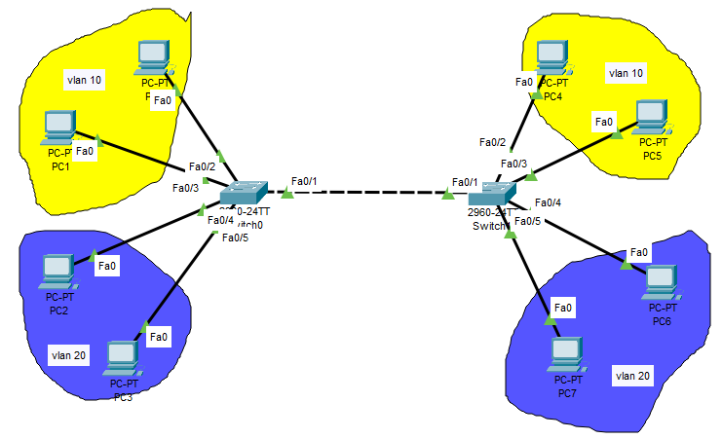

1. **Network Diagram (Packet tracer diagram before configuration):**
2. **Configuration details:**

| **Device Name** | **Interface Name** | **IP Address** | **Subnet mask** |
| --- | --- | --- | --- |
|  |  |  |  |
|  |  |  |  |
|  |  |  |  |
|  |  |  |  |
|  |  |  |  |
|  |  |  |  |

1. **Describe step by step configuration steps properly (you may copy the commands used in the configuration tab and paste it.)**
   * + 1. **Create VLANs**
       2. **Configure interfaces**
       3. **Configure trunking**
2. **Output Diagram (Minimum 3 screenshot):**

**Google Drive link of the packet tracer file (give view permission):**

**Link:**

**CONCLUSION (provide conclusion about this experiment):**

**Rubrics for Experiment Assessment:**

| **Rubrics** | **Good** | **Normal** | **Poor** | **Marks** |
| --- | --- | --- | --- | --- |
| **Creation of Topology (4)** | Created the topology, Identify the proper devices and making the connections **(4)** | Created the topology, Identify the proper devices, making the connections But missing some features **(3)** | Created wrong topology, Failed to Identify the proper devices and making connections **(1)** |  |
| **Verify the connectivity (4)** | Verified the connectivity in all the levels **(4)** | Verified the connectivity at some levels (only some nodes) **(2)** | Verified the connectivity is not done. **(1)** |  |
| **Timely Completion (2)** | Completed the lab before the allotted time **(2)** | Completed the lab after the deadline **(1)** | Did not submitted before grading **(0)** |  |
| **Tota**l | | | |  |